A

Real Time Research Project Report

On

“CampusConnect – A Full-Stack Web Application for Student Networking and Learning Resources”
Submitted in partial fulfillment of the Requirements for the award of the degree of

Bachelor of Technology In
Computer Science & Engineering By

A.AKHILANDESWARI- 23R21A05R9 M.SATWIKA - 23R21A05W

P.SRINATH - 23R21A05Y0

M.VENKATESH - 23R21A05W4

Under the guidance of
Mrs.M.Vineesha
Associate Professor

Department of Computer Science & Engineering



Department of Computer Science & Engineering

CERTIFICATE

This is to certify that the project entitled “Campus Connect-College Resource Hub” has been submitted by Allam Akhilandeswari(23R21A05R9), Makineni Satwika(23R21A05W3), Potharaju Srinath(23R21A05Y0), Maloth Venkatesh(23R21A05W4) in partial fulfillment of the requirements for the award of degree of Bachelor of Technology in Computer Science and Engineering from MLR Institute Of Technology, Hyderabad. The results embodied in this project have not been submitted to any other University or Institution for the award of any degree or diploma.

Internal Guide Head of the Department

External Examiner



Department of Computer Science & Engineering

DECLARATION

We hereby declare that the project entitled “Campus Connect-College Resource Hub” is the work done during the period from July 2024 to April 2025 and is submitted in partial fulfillment of the requirements for the award of degree of Bachelor of Technology in Computer Science and Engineering from MLR Institute Of Technology, Hyderabad. The results embodied in this project have not been submitted to any other university or Institution for the award of any degree or diploma.

Allam Akhilandeswari 23R21A05R9
Makineni Satwika 23R21A05W3
Potharaju Srinath 23R21A05Y0
Maloth Venkatesh 23R21A05W4



Department of Computer Science & Engineering

ACKNOWLEDGEMENT

The satisfaction and euphoria that accompany the successful completion of any task would be incomplete without the mention of people who made it possible, whose constant guidance and encouragement crowned our efforts with success. It is a pleasant aspect that we now have the opportunity to express our guidance for all of them.
First of all, we would like to express our deep gratitude towards our internal guide Mrs.M.Vineesha, Associate Professor, Department of CSE for his support in the completion of our dissertation. We wish to express our sincere thanks to Dr. A. BALARAM, HOD, Department of CSE and also Principal Dr. K. SRINIVAS RAO for providing the facilities to complete the dissertation.

We would like to thank all our faculty and friends for their help and constructive criticism during the project period. Finally, we are very much indebted to our parents for their moral support and encouragement to achieve goals.

Allam Akhilandeswari 23R21A05R9
Makineni Satwika 23R21A05W3
Potharaju Srinath 23R21A05Y0
Maloth Venkatesh 23R21A05W4



Department of Computer Science & Engineering

ABSTRACT

Navigating college life can be overwhelming for students due to the scattered nature of essential academic and campus-related information. From searching for lecture notes and understanding placement requirements to staying updated on events, exam schedules, and scholarship opportunities, the absence of a centralized platform often leads to confusion and missed opportunities. To solve this, we present College Resource Hub, a web-based platform designed to streamline the student experience by centralizing all necessary academic and campus-related resources. The platform offers subject-specific notes, placement procedures, workshop details, extracurricular updates, and student profiles to foster peer-to-peer networking. Beyond being an academic repository, the platform includes dynamic tools like company-specific placement materials, course outlines, project guidelines, and exam preparation tips. It also keeps students informed about campus news, club activities, mentorship programs, and academic calendars. With an intuitive, responsive interface and features like advanced search, personalized dashboards, and secure login, it ensures ease of access, data privacy, and a seamless experience across devices. College Resource Hub ultimately aims to save time, improve access to accurate information, and build a connected, informed, and prepared student community.

LIST OF FIGURES & TABLES

Figure Number | Name of the Figure | Page Number
3.1.1 | Proposed System Diagram | 4
3.3.1 | System Architecture | 5
3.4.1 | Use Case Diagram | 9
3.4.2 | Class Diagram | 10
3.4.3 | Activity Diagram | 10
3.4.4 | Sequence Diagram | 11
3.4.5 | Collaboration Diagram | 12
3.4.6 | Deployment Diagram | 12
3.4.7 | Component Diagram | 13
5.1.1 | Module Diagram | 17
7.1 | Home Page | 35
7.2 | Dashboard Page | 36
7.3 | Notes Repository Page | 37
7.4 | Placement Info Page | 38
7.5 | Event Updates Page | 39
7.6 | Student Profiles Page | 40
7.7 | Admin Panel | 41

 | INDEX
CERTIFICATE |  | i
DECLARATION |  | ii
ACKNOWLEDGEMENT |  | iii
ABSTRACT |  | iv
LIST OF FIGURES & TABLES |  | v
CHAPTER 1  INTRODUCTION |  | 1
1.1 Overview |  | 1
1.2 Purpose of the project |  | 1
1.3 Motivation |  | 1
CHAPTER 2
LITERATURE SURVEY |  | 2
2.1 Existing System |  | 2
2.2 Disadvantages of Existing System |  | 5
CHAPTER 3
PROPOSED SYSTEM |  | 6
3.1 Proposed System |  | 6
3.2 Advantages of Proposed System |  | 7
3.3 System Architecture |  | 7
3.4 UML Diagrams |  | 10
CHAPTER 4  SYSTEM REQUIREMENTS |  | 15
4.1 Software Requirements |  | 15
4.2 Hardware Requirements |  | 15
4.3 Functional Requirements |  | 15
4.4 Non-Functional Requirements |  | 16
CHAPTER 5
MODULE DESIGN |  | 17
5.1 Module Design |  | 17
CHAPTER 6  IMPLEMENTATION |  | 19
6.1 Source Code |  | 19

CHAPTER 7
RESULTS 28
CHAPTER 8
CONCLUSION 33
FUTURE ENHANCEMENTS AND DISCUSSIONS 33
REFERENCES 34

CHAPTER 1
INTRODUCTION
  - OVERVIEW
In our increasingly digital academic environment, students often struggle with the scattered availability of important resources such as lecture notes, placement details, event announcements, and academic schedules. This disorganization leads to confusion, inefficiency, and missed opportunities. To address these challenges, College Resource Hub (Campus Connect) is introduced as an all-in-one web-based platform that centralizes and streamlines access to essential academic and campus-related information. By providing a structured and user-friendly interface, the platform enhances the way students, faculty, and administrators interact with critical resources—promoting better communication, and a more connected campus community.

PURPOSE OF THE PROJECT
The primary goal of College Resource Hub is to create a comprehensive platform that caters to various student needs—academic, extracurricular, and professional. The portal will host a range of features such as subject-wise notes, placement procedures, eligibility criteria, workshop and seminar updates, and peer networking tools through student profiles. It is intended to reduce the dependency on scattered sources and manual information retrieval by providing a one-stop resource hub that supports students throughout their academic journey.

MOTIVATION

The motivation behind this project stems from the common struggles faced by students in accessing timely and relevant information. The digital era demands smarter solutions for academic support and peer collaboration. By centralizing essential data and offering tools for personalized learning and preparation, this platform aims to empower students, enhance productivity, and foster a more connected campus environment. Additionally, it supports faculty and administrators by offering a structured communication and resource-sharing channel, thereby improving the overall educational ecosystem.

CHAPTER 2

LITERATURE SURVEY

An extensive literature survey has been conducted to understand the existing systems and technologies used in educational resource management platforms, campus portals, and centralized academic tools. The goal was to evaluate how digital systems have been employed to improve student engagement, academic performance, and access to institutional resources. Various systems have been studied, ranging from LMS (Learning Management Systems) and ERP (Enterprise Resource Planning) platforms to custom web portals designed for specific college or university needs.

EXISTING SYSTEM

Current systems designed to support students academically and socially are often fragmented, with limited integration across modules like academics, placements, and extracurricular activities. Traditional portals tend to be static, with outdated interfaces and insufficient personalization. Additionally, students frequently rely on third-party tools for specific needs like accessing notes or tracking events, leading to inefficiencies and data silos.
G. Siemens and S. Downes introduced the concept of connectivism in online learning environments, emphasizing the role of digital networks in education. Their research supported the creation of systems that enable students to self-organize learning resources and connect with peers, aligning with the peer-to-peer features of the College Resource Hub.
M. Al-Ajlan and H. Zedan analyzed the use of Learning Management Systems (LMS) and highlighted issues of usability, personalization, and accessibility. They emphasized the importance of user-friendly interfaces, adaptive content, and real-time feedback mechanisms in improving student interaction with online portals.
P. Dillenbourg focused on collaborative learning environments and how effective group formation and resource sharing enhance knowledge retention. These ideas influence the inclusion of student profiles and study group features in the College Resource Hub.
R. McGreal explored open educational resources (OERs) and their impact on academic equity. His findings showed that centralized repositories offering free and structured notes and materials significantly boost academic accessibility—a principle foundational to our notes and document-sharing feature.
J. Singh et al. proposed a dynamic academic portal that integrates course materials, assessments, and placement data. Their model proved effective in reducing administrative overhead and student confusion, laying groundwork for systems like the College Resource Hub.
S. Graf and Kinshuk presented adaptive educational hypermedia systems, which personalize content delivery based on user behavior and preferences. The personalization feature in our proposed system draws heavily from their work, especially in customizing dashboards and academic recommendations.
T. Anderson and L. Rourke studied asynchronous learning networks and the use of forums and messaging tools in fostering student interaction. This research supports the inclusion of discussion modules and peer connectivity in our system.
M. Khosrow-Pour emphasized the role of ERP systems in higher education, advocating for tightly integrated platforms that streamline administrative, academic, and student services. This influenced our system’s integrated module design.
C. Romero and S. Ventura provided a comprehensive review of educational data mining techniques and discussed how student interaction data could be analyzed for performance tracking and content recommendations. Our system’s data-backed dashboard concept is built on this foundation.
J. Brusilovsky presented adaptive navigation and content frameworks in web-based education, which inspired our use of advanced search functionalities and intuitive UI/UX design.
V. Venkatesh and F. D. Davis researched user acceptance of information systems in education and proposed the TAM (Technology Acceptance Model). This model guided the development of features to ensure high usability and user satisfaction in the College Resource Hub.
J. M. Spector examined the use of educational technology for holistic development, advocating for systems that go beyond academics to support skill-building, workshops, and extracurricular engagement—directly influencing the scope of our platform.

DISADVANTAGES OF EXISTING SYSTEM

Concisely summarizing the disadvantages of the above implementations:
- Fragmented platforms force students to switch between multiple tools for academic, placement, and extracurricular needs.
- Lack of real-time updates often leads to outdated or missed information.
- Minimal personalization and static interfaces reduce user engagement and accessibility.
- Absence of centralized peer-to-peer networking restricts collaborative learning opportunities.
- Limited integration across departments and modules results in inefficient data management and redundancy.

CHAPTER 3 PROPOSED SYSTEM
  - PROPOSED SYSTEM

The CampusConnect – Centralized Resource and Community Hub project proposes a smart, web-based system designed to streamline academic resource sharing, event management, and student-faculty interaction within college campuses. The system integrates modern web technologies to offer a seamless, role-based platform where faculty can upload learning materials, and students can access notes, participate in discussions, and stay updated on events and announcements.
CampusConnect begins with user registration and authentication using secure login mechanisms. Role-based access ensures that faculty can upload academic resources, while students can download and interact with community features such as discussions, chatbot assistance, and event participation. The project utilizes real-time databases for fast content delivery and dynamic rendering of posts, events, and materials.
The platform is designed for scalability and responsiveness, making it accessible across devices. Advanced UI/UX practices and animations enhance user interaction. The inclusion of AI-based chatbot support improves student experience by offering automated help regarding notes, schedules, and common queries. Data is continuously updated, and user engagement metrics help improve platform relevance and usability.
This holistic system ensures a collaborative learning environment, promotes academic resource sharing, and strengthens student engagement through an organized digital ecosystem.
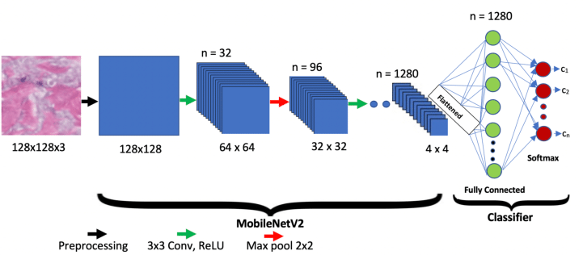

Figure 3.1.1 MobileNetV2
Key Features Embedded in the Algorithm:
- Role-based content visibility (Student vs Faculty)
- Real-time database access for notes and events
- AI chatbot for enhanced interactivity
- Secure login and file handling
- Modular, scalable workflow

ADVANTAGES OF PROPOSED SYSTEM
The proposed CampusConnect system offers the following advantages:
- Role-Based Access Control
Ensures secure and personalized access where faculty can upload notes and events, while students can access materials and participate in the community.
- Centralized Academic Resource Hub
Provides students with easy access to categorized notes, announcements, and event information in a single unified platform.
- AI Chatbot Assistance
Enhances user experience by offering instant support and automated responses to academic and campus-related queries.
- Interactive Learning Community
Encourages student engagement through posts, comments, and discussions, fostering a collaborative learning environment.
- Dynamic & Responsive Design
Built with modern web technologies to ensure accessibility and usability across all devices, from desktops to mobiles.
- Real-Time Event & Announcement Updates
Keeps users informed with instantly updated news, fests, hackathons, and other college activities.
- Continuous Enhancement via Feedback
Regular updates and user feedback loops improve platform usability, chatbot responses, and resource relevance.

SYSTEM ARCHITECTURE

The CampusConnect System Architecture is a modular and scalable framework designed to streamline campus academic activities and foster collaborative learning. This architecture facilitates the integration of note-sharing, event management, AI chatbot assistance, and community interaction into a centralized platform. Each component of the system interacts seamlessly to provide a unified experience for students and faculty, supporting resource distribution, communication, and real-time engagement.
Figure 10.1.1: System Architecture – CampusConnect

User Authentication:
User authentication is the entry point of the EduConnect platform:
- User Roles: Students and Faculty.
- Secure Login: Validates user credentials.
- Role-Based Access: Grants features based on the user's role (upload vs. download).

Dashboard Rendering:
Upon login, users are redirected to their role-based dashboards:
- Faculty Dashboard:
  - Upload notes (PDF, DOC).
  - Post events and announcements.
  - Monitor student engagement.
- Student Dashboard:
  - View/download categorized notes.
  - Participate in community discussions.
  - View upcoming events and alerts.

Notes Management System:
This module manages the academic material repository:
- Faculty Upload: Notes are uploaded via a UI, stored in Firebase/Cloud Storage.
- Notes Categorization: Based on branch, year, and subject.
- Student Access: Download notes as per their enrolled subjects and year.

Event and Announcement Module:
This module handles campus-wide event notifications and updates:
- Event Creation (Faculty/Admin): Tech fests, hackathons, seminars.
- Announcement Cards: Displayed dynamically with filters and pagination.
- Event Calendar Integration: Future feature to notify via timeline view.

Community Interaction Module (Chey Community):
EduConnect fosters a digital community space:
- Post Sharing: Students can create discussion posts.
- Engagement: Like, comment, and interact with other users.
- Moderation: Spam control and basic content review.

AI Chatbot Module:
EduConnect integrates an intelligent assistant using an LLM-based API:
- Query Support: Students can ask academic and event-related queries.
- Context Awareness: Chatbot uses context to improve answers over time.
- 24/7 Availability: Acts as a virtual guide for the platform.

File Storage & Database:
- Notes Storage: Firebase Cloud Storage / MongoDB GridFS.
- User Data: Stored securely in MongoDB (user profiles, uploads, messages).
- Events & Community Data: Stored with timestamps, user IDs, and content metadata.

Feedback & Analytics Module:
Captures user behavior and system performance for continuous improvement:
- Usage Logs: Track downloads, logins, queries.
- Performance Analytics: Real-time usage stats.
- User Feedback: Suggestions submitted by users to improve features.

System Security & Logout:
- Session Timeout: Auto logout for inactive users.
- Logout Confirmation: "Successfully logged out – Campus Connect. Thanks!"
- Data Protection: All communications use HTTPS and secure tokens.

Would you like a diagram or flowchart based on this architecture description? I can generate one visually for your report.
You said:

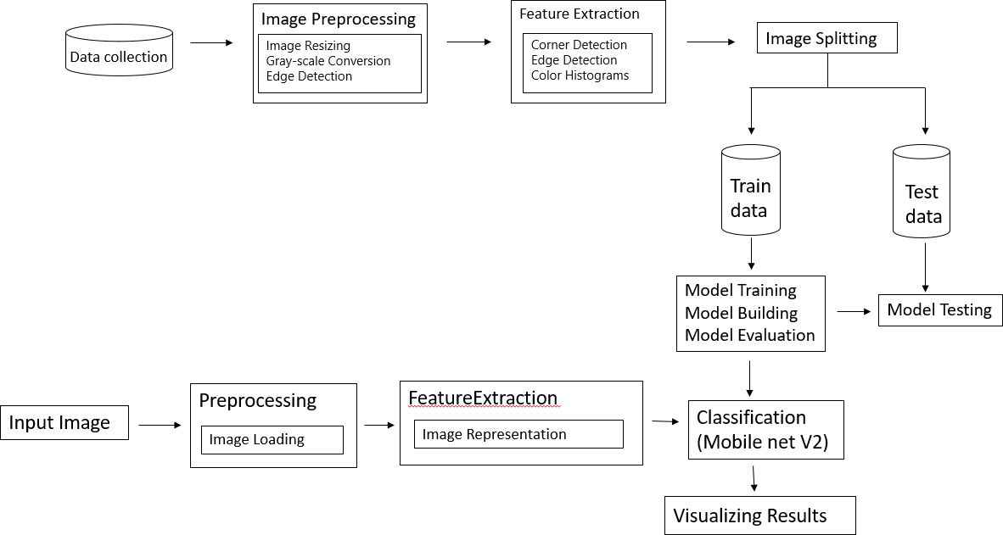
Figure 3.3.1 System Architecture

UML DIAGRAMS
Unified Modeling Language (UML) is a standardized general-purpose modeling language in the field of object-oriented software engineering. It is maintained by the Object Management Group (OMG) and is intended to provide a standard way to visualize the design of a system. UML is useful in specifying, visualizing, constructing, and documenting the artifacts of software systems, and is also applicable in business process modeling and non-software systems.

Use Case Diagram for CampusConnect
The Use Case Diagram provides a graphical overview of the functionality offered by EduConnect. It shows various actors (students, faculty, admin) and their interactions with system features.
Main Actors:
- Student
- Faculty
- Admin
Use Cases:
- Register/Login
- View/Upload Notes (Faculty only)
- Access Chatbot
- Post in Community
- View Events
- Manage User Roles (Admin)
(Figure 3.4.1: Use Case Diagram for EduConnect)

Class Diagram for CampusConnect
The Class Diagram refines the use case diagram and details the structure of the system. It includes classes like User, Student, Faculty, Admin, Note, Event, CommunityPost, and Chatbot.
- User is a base class with attributes like name, email, password, and methods like login(), logout().
- Student, Faculty, and Admin inherit from User.
- Note has attributes like title, pdfFile, uploadedBy, and a method downloadNote().
- CommunityPost has attributes like content, timestamp, postedBy.
- Relationships:
  - Student "has-a" CommunityPost
  - Faculty "has-a" Note
(Figure 3.4.2: Class Diagram for CampusConnect)

Activity Diagram for CampusConnect
The Activity Diagram captures the workflow of key features, such as a student logging in, viewing notes, and posting in the community.
Example:
- Start → Login → Select Feature (Notes/Community/Chatbot/Events) → Perform Action → Logout → End
(Figure 3.4.3: Activity Diagram for CampusConnect
Sequence Diagram for CampusConnect
The Sequence Diagram outlines how objects interact over time, for example, when a faculty member uploads a note:
- Faculty logs in
- Selects “Upload Notes”
- Uploads PDF
- Server saves file
- Database stores metadata
- Confirmation sent back
(Figure 3.4.4: Sequence Diagram for CampusConnect)

Collaboration Diagram for CampusConnect
The Collaboration Diagram groups object interactions, for example:
- Faculty interacts with NotesUploadService
- NotesUploadService interacts with DatabaseService and FileStorage
These interactions are numbered and help trace how each part of the system works together.
(Figure 3.4.5: Collaboration Diagram for CampusConnect t)

Deployment Diagram for CampusConnect
The Deployment Diagram shows the runtime architecture of EduConnect:
- Client Side: Browser / Mobile App
- Server Side:
  - Web Server (Node.js/Express)
  - Database (MongoDB)
  - Storage (Firebase / Local Disk)
  - Chatbot Service (e.g., Gemini API)
Connections are shown via secure protocols (HTTPS, WebSocket for real-time).
(Figure 3.4.6: Deployment Diagram for CampusConnect)

Component Diagram for CampusConnect
The Component Diagram represents the high-level system parts:
- Auth Module
- Notes Module
- Events Module
- Community Module
- Chatbot Integration
- Role-based Access Controller
Each component interacts via defined interfaces and APIs.
(Figure 3.4.7: Component Diagram for CampusConnect)

CHAPTER 4 SYSTEM REQUIREMENTS
The system requirements for the development and deployment of the project as an application are specified in this section. These requirements are not be confused with the end-user system requirements. There are no specific, end-user requirements as the intended application is cross-platform and is supposed to work on devices of all form-factors and configurations.

Certainly! Below is a detailed version of the System Requirements section for the
CampusConnect – Smart Campus Resource Hub project, including software, hardware, functional, and non-functional requirements tailored for the platform.

4.1 SOFTWARE REQUIREMENTS
The following software components are necessary for the development and deployment of CampusConnect – Smart Campus Resource Hub:
- Software:
  - Node.js (JavaScript runtime environment)
  - NPM (Node Package Manager for managing dependencies)
  - MongoDB (NoSQL database to store user data, notes, events, and community content)
  - Mongoose (ODM for MongoDB and Node.js)
  - Anaconda (for Python environment management, used for Machine Learning integration)
- Primary Language:
  - JavaScript (used for both frontend and backend)
  - Python (for Machine Learning tasks using models like Mistral API)
- Frontend Framework:
  - React.js (to create interactive and responsive user interfaces)
  - Redux (for state management)
  - HTML, CSS, JavaScript, and Bootstrap4 (for the frontend layout and design)
- Backend Framework:
  - Express.js (backend web framework for handling API requests)
  - Mistral API (for integrating Machine Learning functionalities)
  - Node.js (server environment for executing JavaScript code)
- Database:
  - MongoDB (for storing user data, notes, events, and community content)
  - Mongoose (to interact with MongoDB using JavaScript)
- Machine Learning:
  - TensorFlow.js or Scikit-learn (for implementing machine learning models in JavaScript or Python)
  - Mistral API (used for chat-based interactions and intelligent responses)
- Additional Tools:
  - Git (version control system)
  - Docker (containerization for environment setup)
  - Postman (for API testing)

4.2 HARDWARE REQUIREMENTS
To ensure optimal development and deployment performance, the following hardware requirements are specified for application development:
- Operating System: Windows (only for the development environment)
- Processor: Intel i5 or higher (to handle computational tasks efficiently)
- RAM: 8GB or more (to support smooth operation and multitasking)
- Hard Disk: 25GB of free space (for storing project files, databases, and application data)

4.3 FUNCTIONAL REQUIREMENTS
These are the key functional features that EduConnect must implement:
- User Authentication and Role Management:
  - Secure login and registration functionality for students and faculty.
  - Role-based access (Faculty: Upload notes, manage events; Students: Download notes, join discussions).
- Notes Management System:
  - Upload and organize academic notes by faculty in a structured format (PDF, DOC).
  - Enable students to browse, search, and download notes based on their course.
- Event and Announcement Module:
  - Faculty can create and post campus events, hackathons, and seminars.
  - Students can view upcoming events and receive notifications.
- Community Interaction (Chey Community):
  - Allow students to post discussion topics and engage with others through likes and comments.
  - Facilitate peer-to-peer communication within the campus community.
- AI Chatbot:
  - Implement an AI chatbot that answers user queries related to events, notes, and general campus information.
  - Continuous learning to improve response accuracy and handle user feedback.
- Feedback and Analytics:
  - Collect feedback from users on notes, events, and chatbot interactions.
  - Display real-time analytics for system usage, events, and engagement.
- Data Collection and Integration:
  - Integrate and preprocess user-generated data, such as notes uploads, community posts, and feedback.

4.4 NON-FUNCTIONAL REQUIREMENTS
These non-functional requirements ensure the application performs effectively and meets user expectations:
- Accuracy:
  - Ensure that the AI chatbot and event categorization algorithms are accurate and relevant.
  - Notes classification and event management should be precise and reliable.
- Reliability:
  - The system should maintain high availability, with minimal downtime.
  - The platform must be robust and function correctly under varied usage loads.
- Usability:
  - The user interface should be intuitive and easy to navigate, ensuring a smooth experience for both students and faculty.
  - Ensure that the platform is accessible and responsive across different devices (desktops, tablets, smartphones).
- Compatibility:
  - The system should integrate seamlessly with other commonly used tools and platforms such as cloud storage services, email services, and external event APIs.
  - It should work on different browsers and be compatible with the major operating systems (Windows, macOS, Linux).
- Scalability:
  - The system should be designed to scale as the number of users increases, especially in terms of event participation, file storage, and community interactions.

CHAPTER 5
MODULE DESIGN
5.1 MODULE DESIGN

The module design for CampusConnect – Smart Campus Resource Hub divides the system into smaller components, each responsible for specific tasks to ensure efficient functionality and scalability. The following are the key modules that make up the CampusConnect system:

Figure 5.1.1 Module Diagram
- User Authentication and Authorization Module:
  - Purpose: This module manages user registration, login, and access control, ensuring that students and faculty can securely log into the system and access only the data relevant to them based on their roles.
  - Responsibilities:
    - User registration with email and password.
    - Secure login and session management using JWT tokens.
    - Role-based access control (faculty vs. student).
    - Password reset functionality.
- Notes Management Module:
  - Purpose: The Notes Management Module allows faculty to upload academic resources (such as lecture notes, study materials, PDFs), which are stored in the database and made accessible to students.
  - Responsibilities:
    - Uploading, organizing, and storing academic notes and materials.
    - Allowing students to search and download the notes.
    - Ensuring that only faculty can upload content, with a proper content categorization system.
- Event Management Module:
  - Purpose: This module helps faculty and administrators to create, manage, and post events, seminars, and announcements to the platform, while students can explore and register for these events.
  - Responsibilities:
    - Event creation by faculty (title, date, description, location, etc.).
    - Displaying event listings for students.
    - Registration and attendance tracking for events.
    - Sending notifications or reminders to users about upcoming events.
- Community Interaction Module (Chat Community):
  - Purpose: The community interaction module enables students to post discussion topics, engage in conversations, and share resources. It facilitates peer-to-peer interaction and collaboration on various subjects.
  - Responsibilities:
    - Student posts, comments, and replies in forums/discussion boards.
    - Like/dislike and tagging functionality for posts.
    - Moderation and reporting features.
    - Discussion categorization (e.g., General, Technical, Campus Life).
- AI Chatbot Integration Module (Mistral API):
  - Purpose: This module integrates the AI chatbot, which provides intelligent responses to user queries related to campus events, notes, general information, and more, powered by the Mistral API.
  - Responsibilities:
    - Receive and process user queries.
    - Provide relevant responses based on available data and knowledge.
    - Learn from user interactions to continuously improve performance.
    - Handle queries related to notes, events, campus information, and FAQs.
- Machine Learning Integration Module:
  - Purpose: This module incorporates machine learning algorithms to provide personalized suggestions for notes and events to students, based on their preferences and previous interactions.
  - Responsibilities:
    - Use machine learning models to analyze user behavior (clicks, downloads, posts) and recommend related events or notes.
    - Analyze feedback to improve system recommendations over time.
    - Track user interests and provide tailored learning paths or study materials.
- Database Integration Module:
  - Purpose: This module ensures smooth communication between the backend system and MongoDB, which stores user data, notes, events, and community posts.
  - Responsibilities:
    - Data retrieval and storage using MongoDB for different entities (users, notes, events, posts).
    - Ensuring data consistency and managing CRUD operations (Create, Read, Update, Delete).
    - Backup and optimization for database performance.
- User Interface (UI) Module:
  - Purpose: The UI module is responsible for rendering the front-end of the platform, ensuring that students and faculty can easily interact with the system. It must be visually appealing, responsive, and intuitive.
  - Responsibilities:
    - Displaying data fetched from the backend (notes, events, posts).
    - Implementing responsive designs for various devices (desktops, tablets, mobiles).
    - Facilitating navigation between different sections (Home, Notes, Events, Community).
    - Providing user-friendly forms for registration, login, feedback, etc.
    - Incorporating animations, transitions, and modern UI elements using CSS, JavaScript, and Bootstrap.
- Notification and Alert Module:
  - Purpose: This module manages notifications for important updates, such as new notes uploads, upcoming events, new discussions in the community, and responses from the AI chatbot.
  - Responsibilities:
    - Push notifications for events, new notes, and replies to posts.
    - Real-time notification management using WebSockets or third-party services.
- Analytics and Feedback Module:
  - Purpose: This module collects user feedback and system analytics to improve overall platform performance and user experience.
  - Responsibilities:
    - Collect feedback from students and faculty about notes, events, and the AI chatbot.
    - Generate reports on system usage, popular events, and notes.
    - Analyze user engagement to inform improvements.

This modular approach ensures that each component of CampusConnect is manageable and can be developed, tested, and deployed independently. It also allows for scalability as new features or modules can be added without disrupting the overall system.

CHAPTER 6

IMPLEMENTATION

6.1 SOURCE CODE

CampusConnect – Implementation Code

5.1 Frontend - React (App.js)
import React from "react";
import { BrowserRouter as Router, Routes, Route } from "react-router-dom";
import LoginPage from "./pages/LoginPage";
import RegisterPage from "./pages/RegisterPage";
import Dashboard from "./pages/Dashboard";
import Navbar from "./components/Navbar";
function App() {
return (
<Router>
<Navbar />
<Routes>
<Route path="/" element={<LoginPage />} />
<Route path="/register" element={<RegisterPage />} />
<Route path="/dashboard" element={<Dashboard />} />
</Routes>
</Router>
);
}
export default App;

5.2 Frontend - Login Page
import React, { useState } from "react";
import axios from "axios";
import { useNavigate } from "react-router-dom";
function LoginPage() {
const [email, setEmail] = useState("");
const [password, setPassword] = useState("");
const navigate = useNavigate();
const login = async () => {
try {
const res = await axios.post("http://localhost:5000/api/auth/login", { email, password });
localStorage.setItem("token", res.data.token);
navigate("/dashboard");
} catch (err) {
alert("Invalid credentials");
}
};
return (
<div>
<input placeholder="Email" onChange={e => setEmail(e.target.value)} />
<input placeholder="Password" type="password" onChange={e => setPassword(e.target.value)} />
<button onClick={login}>Login</button>
</div>
);
}
export default LoginPage;

5.3 Backend - Auth Route
const express = require("express");
const router = express.Router();
const User = require("../models/User");
const bcrypt = require("bcryptjs");
const jwt = require("jsonwebtoken");
router.post("/register", async (req, res) => {
const { name, email, password } = req.body;
const hashedPass = await bcrypt.hash(password, 10);
const user = new User({ name, email, password: hashedPass });
await user.save();
res.send({ message: "User Registered" });
});
router.post("/login", async (req, res) => {
const { email, password } = req.body;
const user = await User.findOne({ email });
const isMatch = await bcrypt.compare(password, user.password);
if (!isMatch) return res.status(401).send({ error: "Invalid credentials" });
const token = jwt.sign({ userId: user._id }, process.env.JWT_SECRET);
res.send({ token });
});
module.exports = router;

5.4 Backend - User Model
const mongoose = require("mongoose");
const userSchema = new mongoose.Schema({
name: String,
email: { type: String, unique: true },
password: String,
profilePic: String,
courses: [String],
points: { type: Number, default: 0 }
});
module.exports = mongoose.model("User", userSchema);

5.5 Server.js
// server.js
require("dotenv").config();
const express = require("express");
const mongoose = require("mongoose");
const cors = require("cors");
const path = require("path");
const multer = require("multer");
const http = require("http");
const socketIo = require("socket.io");

// Models
const User = require("./models/User");
const Community = require("./models/Community");

// Set a default JWT_SECRET if none is provided in the .env file
process.env.JWT_SECRET = process.env.JWT_SECRET || "educonnect_secure_jwt_secret";

// Add default NODE_ENV if not set
process.env.NODE_ENV = process.env.NODE_ENV || "development";

const userRoutes = require("./routes/userRoutes");
const chatRoutes = require("./routes/chatRoutes");
const groupRoutes = require("./routes/groupRoutes");
const campusConnectRoutes = require("./routes/campusConnectRoutes");
const chatbotRoutes = require("./routes/chatbotRoutes");
const materialRoutes = require("./routes/materialRoutes");
const eventRoutes = require("./routes/eventRoutes");
const forumRoutes = require("./routes/forumRoutes");
const communityRoutes = require("./routes/communityRoutes");

const app = express();
const server = http.createServer(app);
const io = socketIo(server, {
cors: {
origin: "*", // In production, replace with specific origins
methods: ["GET", "POST"]
}
});

// Middleware
app.use(cors());
// Increase payload size limit for base64 images to handle larger files
app.use(express.json({ limit: '10mb' }));
app.use(express.urlencoded({ limit: '10mb', extended: true }));

// Log all incoming requests
app.use((req, res, next) => {
console.log(`${new Date().toISOString()} - ${req.method} ${req.url}`);
next();
});

// Setup multer for file upload (for profile pictures)
const storage = multer.diskStorage({
destination: (req, file, cb) => {
cb(null, "uploads/profilePics"); // Path to store uploaded profile pictures
},
filename: (req, file, cb) => {
cb(null, `${req.params.userId}_${Date.now()}${path.extname(file.originalname)}`);
},
});
const upload = multer({ storage });

// MongoDB connection
const mongoURI = process.env.MONGO_URI || "mongodb://localhost:27017/educonnect";
mongoose
.connect(mongoURI, {
useNewUrlParser: true,
useUnifiedTopology: true,
})
.then(() => console.log("MongoDB connected"))
.catch((err) => console.error("Mongo Error:", err));

// Routes
app.use("/api/users", userRoutes);
app.use("/api/chats", chatRoutes);
app.use("/api/groups", groupRoutes);
app.use("/api/chat", campusConnectRoutes);
app.use("/api/chatbot", chatbotRoutes);
app.use("/api/materials", materialRoutes);
app.use("/api/events", eventRoutes);
app.use("/api/forum", forumRoutes);
app.use("/api/community", communityRoutes);

// Health check endpoint for frontend to verify server connection
app.get("/api/health-check", (req, res) => {
res.status(200).json({ status: "ok", message: "Server is running", timestamp: new Date().toISOString() });
});

// Static file serving for uploaded images
app.use('/uploads', express.static(path.join(__dirname, 'uploads')));

// Socket.io
// Keep track of online users
const onlineUsers = new Map();

io.on("connection", (socket) => {
console.log("New client connected:", socket.id);

// Handle user login
socket.on("login", async (userId) => {
// Associate socket ID with user ID
onlineUsers.set(socket.id, userId);

// Update user's online status
try {
await User.findByIdAndUpdate(userId, {
lastActive: new Date(),
status: 'online'
});

// Broadcast to all users that this user is online
io.emit("userStatusChange", { userId, status: 'online' });

// Get user's communities
const user = await User.findById(userId).populate('communities');
if (user && user.communities) {
// Join socket rooms for each community
user.communities.forEach(community => {
socket.join(`community:${community._id}`);
});
}
} catch (error) {
console.error("Error updating user status:", error);
}
});

// Handle user logout or disconnect
const handleDisconnect = async () => {
const userId = onlineUsers.get(socket.id);

if (userId) {
try {
// Update user's online status
await User.findByIdAndUpdate(userId, {
lastActive: new Date(),
status: 'offline'
});

// Broadcast to all users that this user is offline
io.emit("userStatusChange", { userId, status: 'offline' });

// Remove from onlineUsers
onlineUsers.delete(socket.id);
} catch (error) {
console.error("Error updating user status on disconnect:", error);
}
}

console.log("Client disconnected:", socket.id);
};

socket.on("logout", handleDisconnect);
socket.on("disconnect", handleDisconnect);

// Handle join community
socket.on("joinCommunity", (communityId) => {
socket.join(`community:${communityId}`);
});

// Handle leave community
socket.on("leaveCommunity", (communityId) => {
socket.leave(`community:${communityId}`);
});

// Handle new community message
socket.on("sendCommunityMessage", (message) => {
io.to(`community:${message.community}`).emit("newCommunityMessage", message);
});

// Handle direct message
socket.on("sendDirectMessage", (message) => {
// Find recipient's socket ID
let recipientSocketId = null;
for (const [socketId, userId] of onlineUsers.entries()) {
if (userId === message.recipient) {
recipientSocketId = socketId;
break;
}
}

// Send message to recipient if online
if (recipientSocketId) {
io.to(recipientSocketId).emit("newDirectMessage", message);
}

// Also send to sender for confirmation
socket.emit("newDirectMessage", message);
});

// Handle typing indicator
socket.on("typing", (data) => {
if (data.communityId) {
// Community chat typing
socket.to(`community:${data.communityId}`).emit("userTyping", {
userId: data.userId,
communityId: data.communityId,
isTyping: data.isTyping
});
} else if (data.recipientId) {
// Direct message typing
// Find recipient's socket ID
let recipientSocketId = null;
for (const [socketId, userId] of onlineUsers.entries()) {
if (userId === data.recipientId) {
recipientSocketId = socketId;
break;
}
}

if (recipientSocketId) {
io.to(recipientSocketId).emit("userTyping", {
userId: data.userId,
isTyping: data.isTyping
});
}
}
});
});

// 404 handler - must be after all routes
app.use((req, res) => {
console.log(`404 Not Found: ${req.method} ${req.url}`);
res.status(404).json({ message: `Route not found: ${req.method} ${req.url}` });
});

// Error middleware
app.use((err, req, res, next) => {
console.error("Server Error:", err.stack);
res.status(500).json({
message: "Internal Server Error",
error: process.env.NODE_ENV === 'development' ? err.message : undefined
});
});

const PORT = process.env.PORT || 5001;
server.listen(PORT, () => console.log(`Server running on port ${PORT}`));

CHAPTER 7

RESULTS

EduConnect is a modern, dynamic, full-stack web application designed to streamlinecommunication, learning resources, and engagement between students and faculty within an educational institution. Built with the MERN (MongoDB, Express.js, React.js, Node.js) stack, EduConnect delivers a responsive and user-friendly interface tailored for both mobile and desktop platforms.
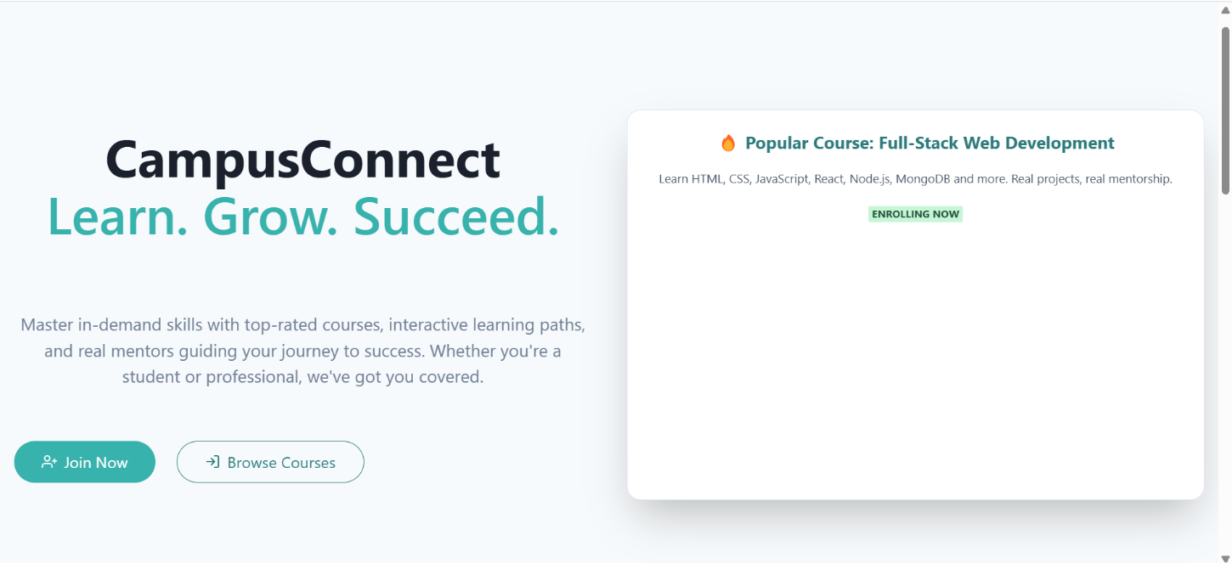
Figure 7.1 Landing Page
CampusConnect Sign-In Page:The EduConnect Sign-In page allows users to log in based on their role as either a student or faculty. Users enter their email and password into the form provided. When they click the "Sign In" button, their credentials are verified from the database. Upon successful verification, they are redirected to their respective dashboard with personalized features.
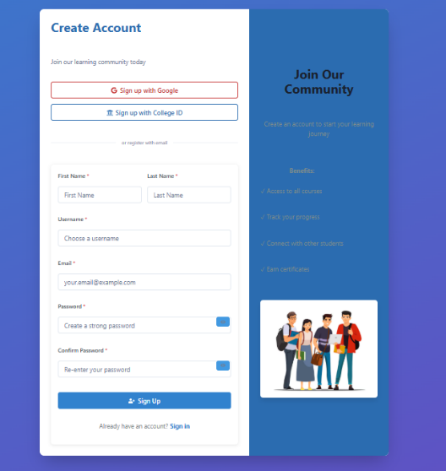
Figure 7.2 Sign In Page

Login Page:
The CampusConnect Login page is the main entry point for users to access the platform. It provides input fields for email and password, along with role selection for students or faculty. After submitting valid credentials, users are authenticated through the backend. Successful login redirects them to a personalized dashboard based on their selected role.
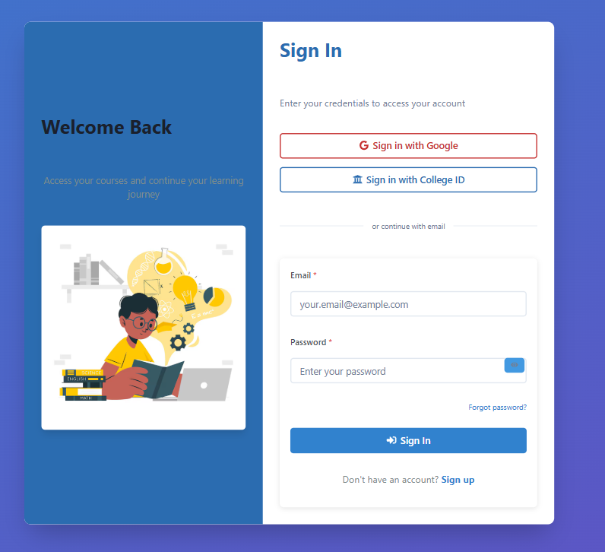

Figure 7.3 Sign Up Page
The CampusConnect Home page serves as the central hub for users after login. It displays a welcome message along with key navigation options like Chatbot, Notes, Community, Events, and Profile Dashboard. The interface is designed to be clean, modern, and responsive, offering easy access to all core features.
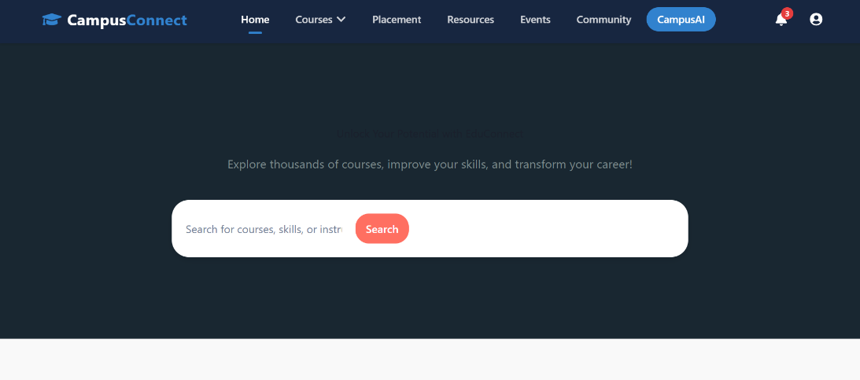
Figure 7.4 Home Page

The Courses page on CampusConnect provides a structured and user-friendly interface for students to explore and access study materials. Courses are organized by branch and semester, allowing easy navigation. Each course includes downloadable PDFs, video links, and important resources to support learning. The page ensures students can quickly find the content they need for academic success.

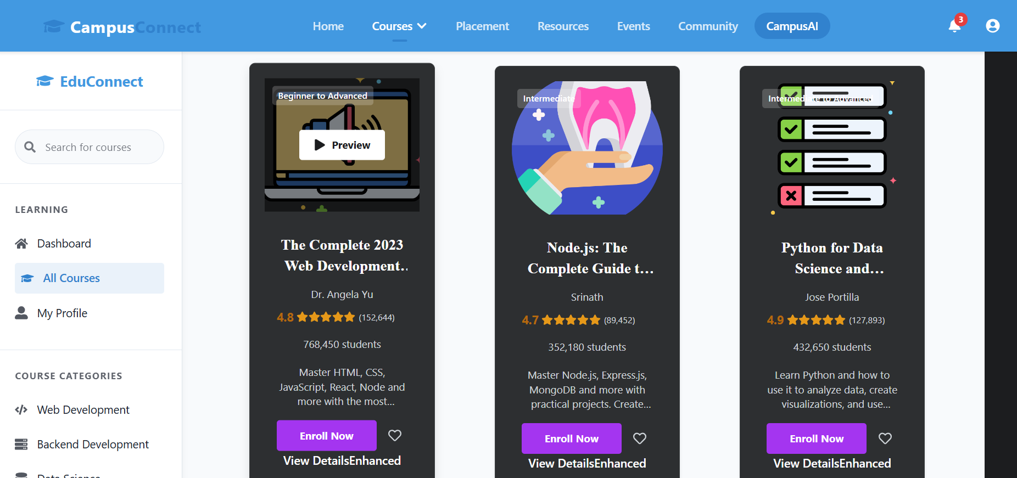

Video lectures:
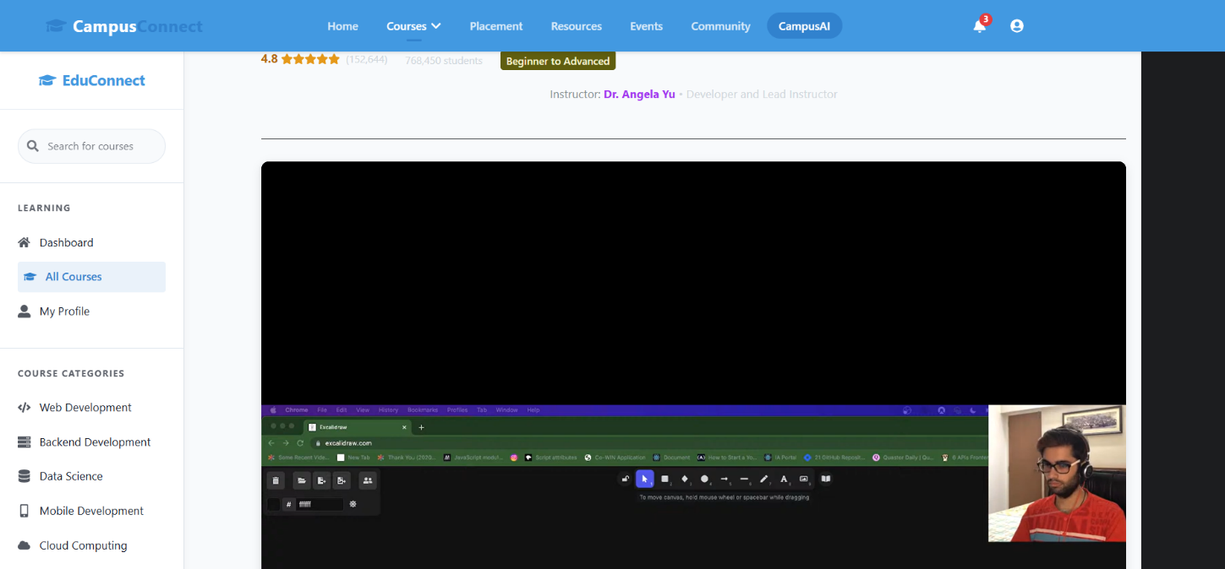

Progress :

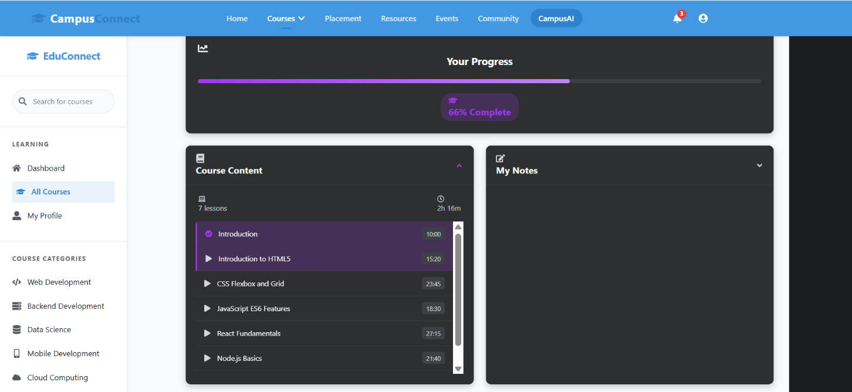

Quiz :

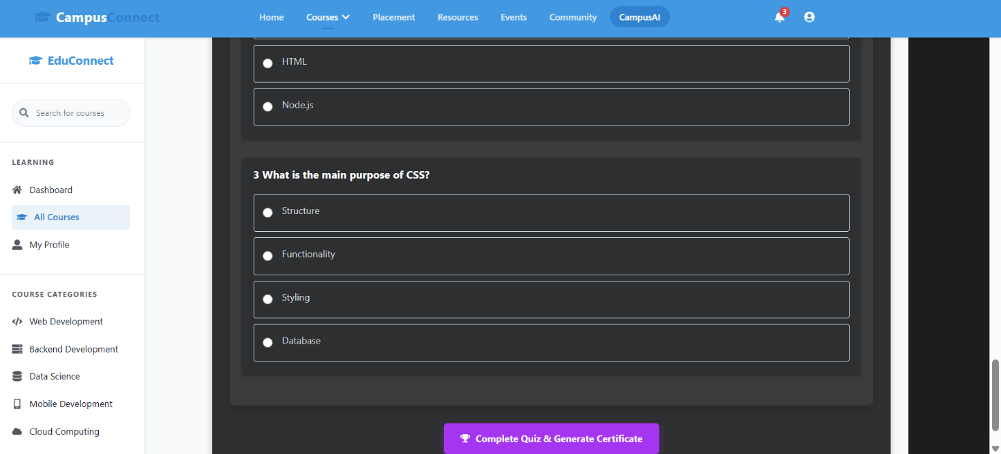

Certification:
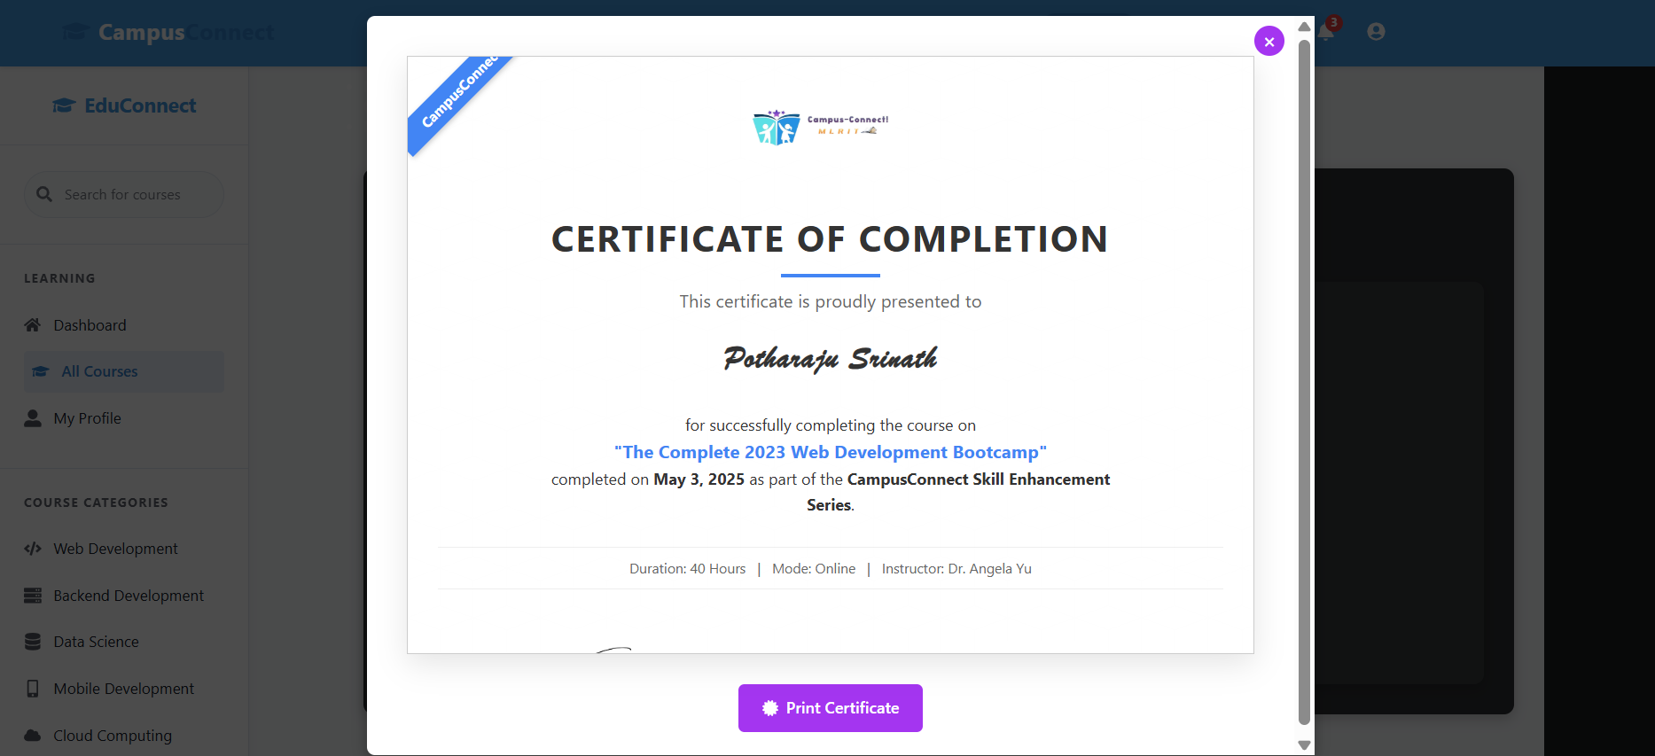 Figure 7.5 Course Page

The Resources page on CampusConnect offers a wide range of educational materials to enhance student learning. It includes previous question papers, important notes, reference books, and useful links. All resources are categorized clearly to help users find what they need efficiently. This page supports self-paced learning by providing reliable and accessible study tools.
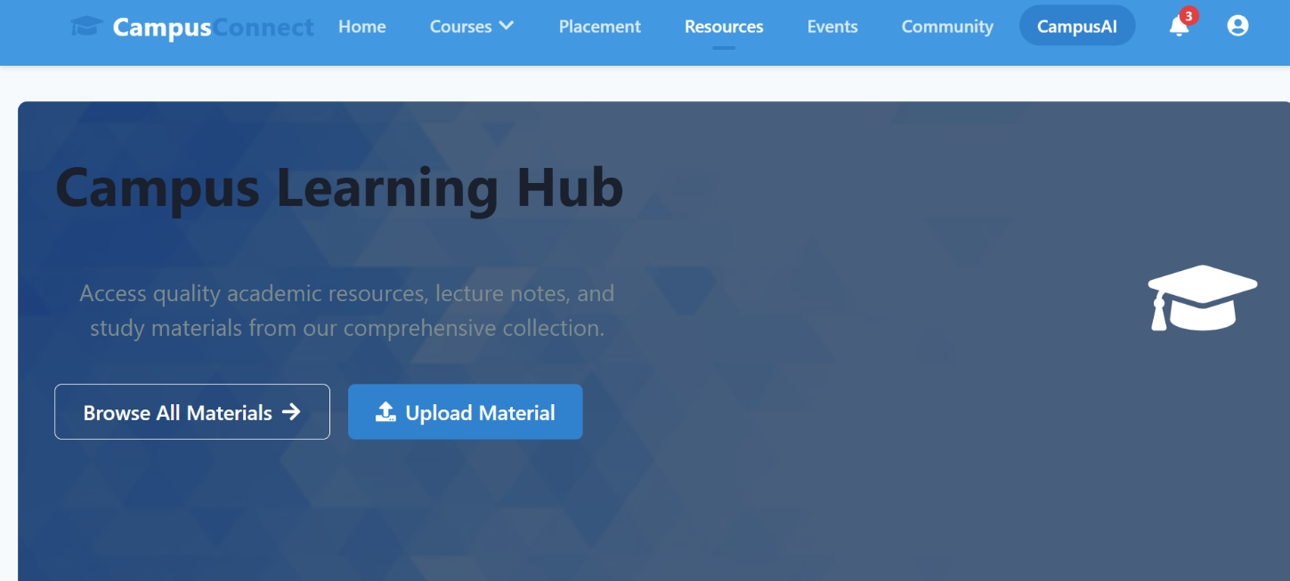

Resources:
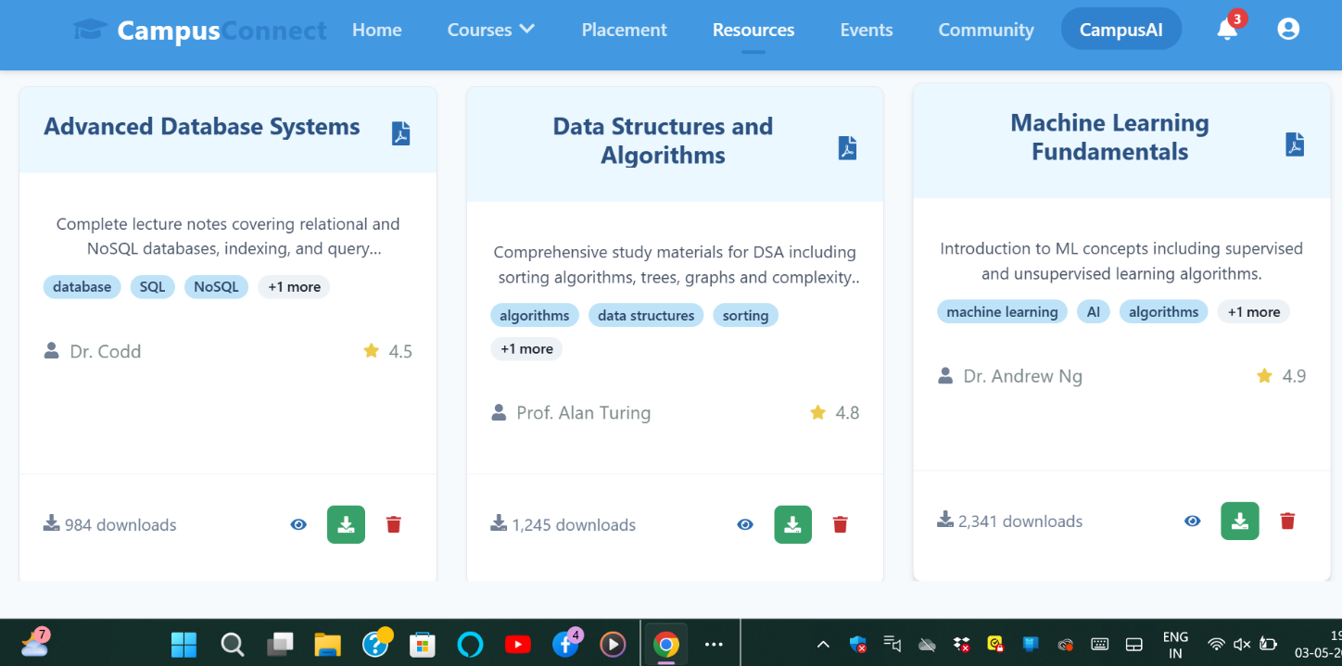

Table 7.1 ResourceTable

The Events page on CampusConnect showcases all upcoming and past campus activities, including tech fests, workshops, seminars, and hackathons. It provides event details like date, time, venue, and description, keeping students informed and engaged. Faculty can post new events, while students can view and register for them. The page helps promote participation and keeps the campus community connected.

Event :

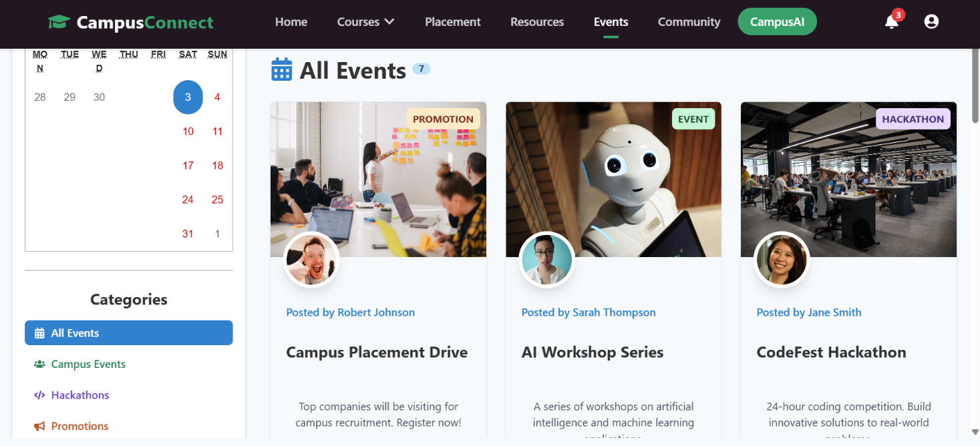

Event :
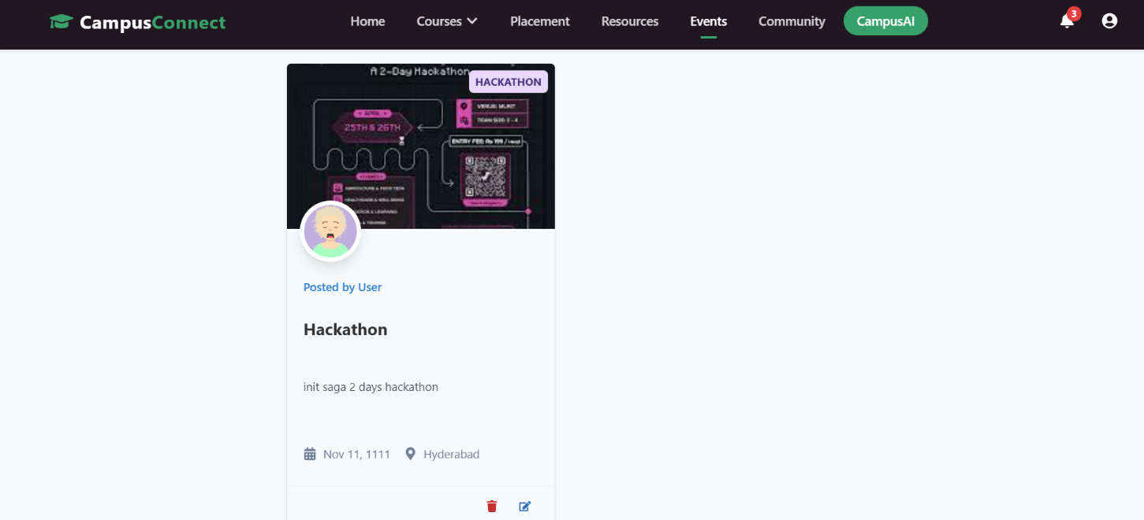

The Community page on CampusConnect serves as a platform for students and faculty to engage in discussions, share ideas, and collaborate on various topics. It allows users to post updates, ask questions, and participate in ongoing conversations related to their academic and extracurricular interests. This page fosters a sense of belonging and promotes active communication within the campus community.

Community :

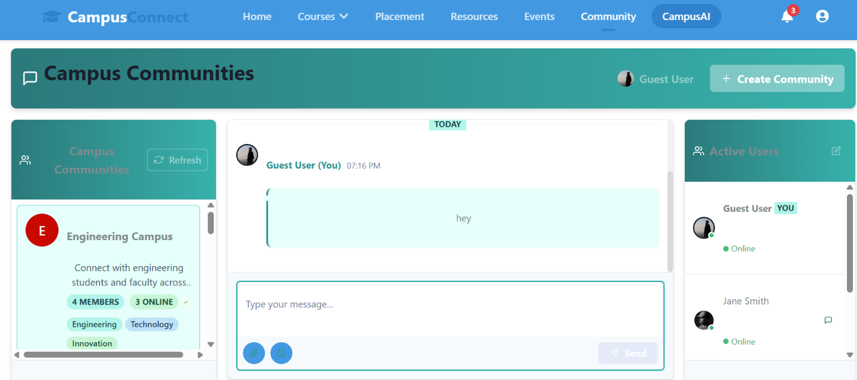

AI Assiatant :

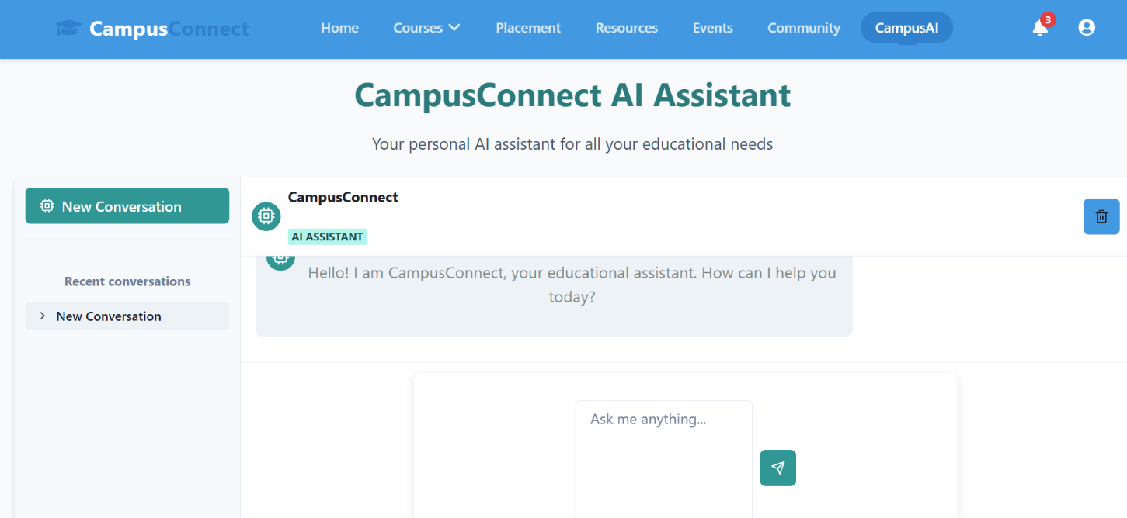

Profile :

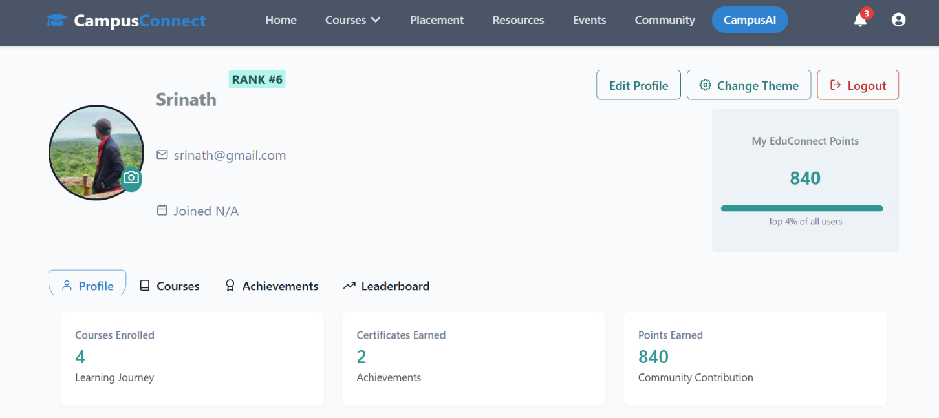

CAMPUS CONNECT!! - An Integrated website for MLRIT

CHAPTER 8

CONCLUSION

In conclusion, CampusConnect offers a dynamic and user-friendly platform for students and faculty, facilitating seamless interaction, learning, and campus engagement. By integrating features like course management, resource sharing, event updates, and a community discussion space, CampusConnect significantly enhances the academic experience. It fosters a sense of belonging and encourages collaboration, ensuring that both students and faculty have easy access to educational tools and resources. The website provides a modern, digital solution for improving communication and knowledge-sharing within educational institutions, contributing to a more connected and informed academic community.

FUTURE ENHANCEMENTS AND DISCUSSIONS
Looking ahead, CampusConnect can evolve by incorporating advanced technologies such as AI-driven personalized learning, gamification elements to boost student engagement, and more sophisticated analytics tools to track student progress. There is potential to expand the platform’s capabilities to support global learning, enabling students and faculty from different institutions to connect, collaborate, and share resources seamlessly. Additionally, integrating features like virtual classrooms, live sessions, and AI-powered tutoring can further enhance the learning experience. CampusConnect’s future lies in continually adapting to the evolving educational landscape, providing more interactive, accessible, and inclusive tools for learners and educators worldwide.

REFERENCES
- insights into the EduConnect platform, its features, and its development:

- 1. EduConnect: Education Website Case Study
- This UI/UX case study explores the comprehensive design of EduConnect, focusing on user-centered design principles, innovative features, and an intuitive interface aimed at enhancing the learning experience. Medium+1Medium+1
- 2. EduConnect 2025 Pricing, Features, Reviews & Alternatives
- This resource provides detailed information on EduConnect's features, including live classes, multi-type marking systems, online exam management, and more. It also offers insights into pricing and user reviews. GetApp
- 3. EduConnect AI CRM Platform
- EduConnect's AI-powered CRM platform offers features like 2-way text messaging, review management, and mobile app integration, aiming to streamline communication and enhance user engagement. Edu Connect AI CRM Platform
- 4. EduConnect: AI Benefits for Universities & Students
- This platform provides AI-powered tools such as AI agents, smart attendance tracking, and personalized support, designed to enhance student engagement and streamline administrative processes. geteduconnect.ai+1geteduconnect.ai+1
- 5. EduConnect: Transform Your Institution with Innovative Solutions
- This article discusses EduConnect's innovative solutions, including interactive community platforms, intelligent task management, and integrated unified calendars, aimed at improving student experience and institutional efficiency.
- Project : https://github.com/sriinathh/e-learning

